**Programare Avansata pe Obiecte  
Laborator 9**

**Pahontu Bogdan-Ionut**

**E-mail:** [**pahontubogdan@gmail.com**](mailto:pahontubogdan@gmail.com)

Contents

1. Java Swing classes 3

1.1. Useful resources 3

1.2. See attached code 3

2. Tasks 4

# Java Swing classes

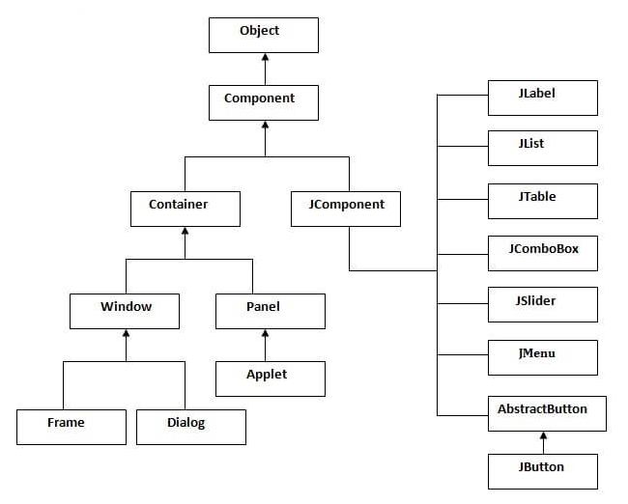

Figure - Java swing hierarchy

## Useful resources

* <https://www.javatpoint.com/java-swing>
* <https://www.tutorialspoint.com/swing/index.htm>
* <https://www.geeksforgeeks.org/java-swing-simple-calculator/>

## See attached code

* Please see the code presented in src/examples in Lab9 project

# Tasks

**Task 1:**

* Create a file with data for one of your entity used in your project;
* Load the data from file using an entity service;
* Create a UI in order to manage that entity:
  + Display the data in a table;
  + Add new / Edit / Delete row;
  + The changes will be stored only in memory (When the program will be restarted we will use the same base data);